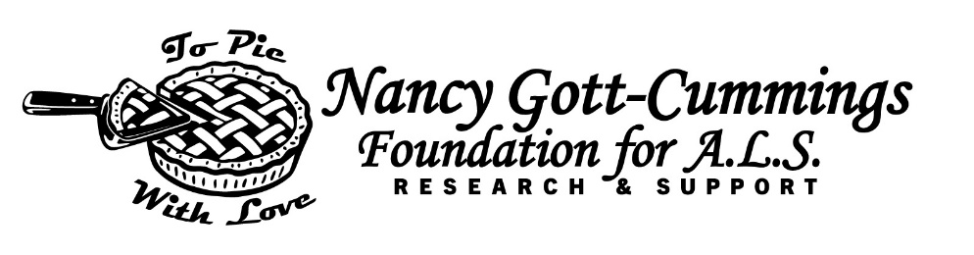

ALS Care Grant: Introduction and Grant Application Steps.
The Nancy Gott Cummings Foundation for ALS Research and Support Care Grant is funded through the work of a charitable organization, operating within a 501C3 corporation, that was established in the state of Florida in 2025. Visit the Foundation website at www.ngcforals.com to learn more.
Funds are meant to assist with costs of living with ALS such as:
- Durable medical equipment and medical supplies
- Home modifications
- In-home and respite care
- Professional services (Examples: allied health providers; therapy and medical appointments)
Grant requests must be related to Healthcare, services or equipment for those in need of support.
Please refer to the Nancy Gott Cummings Foundation for ALS Research and Support Care Grant
Guidelines. The Care grant will provide a maximum benefit of $1000.00 annually and grants are
provided based on availability of funds. Grants will be paid as an expense reimbursement.
The applicant must first incur the expense and then be reimbursed via the grant program.

RECIPIENTS MUST BE A RESIDENT OF THE U.S. OR U.S. TERRITORIES
Steps to Apply for the NGC for ALS Care Grant Program
Step 1: Complete the application form and sign it.
*If this is your first time completing an application, you must submit a Verification of Healthcare Provider form
which must be completed by a licensed healthcare provider.
Step 2: Scan and return the completed forms to INFO@NGCFORALS.COM or send via US Mail to the office address listed on the application form. Please DO include any receipts for reimbursement with your initial application; however, if approved for the grant, you may be asked to show further proof of expenses in case of an audit. Only receipts that meet the approved guidelines will be processed for reimbursement. Remember, please include receipts with your application that total at least the amount of grant applied for.
Step 3: Upon approval, you can anticipate payment in the mail in approximately 3 weeks. Please note that your payment will arrive in the mail and will not include the Nancy Gott Cummings Foundation for ALS Research and Support name or logo; instead, the name Allen Accounting Group will appear in the return address section of the envelope.
Step 4: Once approved, grants will be paid to the primary caregiver noted on the application, provided
that all paperwork has been completed appropriately and necessary receipts have been received by
Nancy Gott Cummings Foundation for ALS Research and Support. You will receive an award letter with
your grant check.

Mail to: The Nancy Gott Cummings Foundation for ALS Research
C/O Allen Accounting Services PO Box 1227
Salmon, Idaho 83467
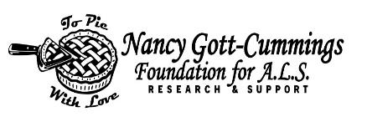 Email to: info@ncgforals.com

ALS Care Grant Application and Authorization Form

Client Name: Date of Diagnosis: Client Address (not a PO Box) City State: Zip: Phone: Email: Do you attend an ALS Clinic? Yes No If yes, name/location of the clinic
Healthcare Provider Name: Are you a Veteran? Yes No Mail check to client OR mail check to caregiver? Client Caregiver Spouse/Caregiver: Relationship: Address if different from client: Preferred Phone: Email:
Purpose  (Refer to instruction sheet if more  information required) | Place “X”  or Check | Expected Cost | Amount Covered by Insurance Y/N | Brief Description
Respite: Hired Care
Home Modification
Medical Equipment
Medication (FDA Approved)
Vehicle Modification
Speech Generating Device
Access to ALS Clinic, ALS Physician/Allied Health Professional
and/or Hospitalization
Special Circumstances: | Please describe:
Policies and Procedures: The Nancy Gott Cummings Foundation for ALS Research and Support Care Grant assists with the care and needs of those living with ALS. The Nancy Gott Cummings Foundation for ALS Research and Support assumes no responsibility or liability for any direct or indirect services, products, or client care, or for the care arrangement and/or business relationship between the ALS client and their selected product or service provider. The Nancy Gott Cummings Foundation for ALS Research and Support will issue an award letter for the ALS Care Grant. The Nancy Gott Cummings Foundation for ALS Research and Support assumes no fiscal responsibility beyond the approved grant amount.
Applicants must sign and date this application, agree to the listed policies and procedures, and mail or email the completed application to the Foundation.

To the best of my knowledge and belief, the information I provided on this application is true, correct, and complete. I have read the all of the Care Grant Policies, Procedures and Eligibilty Requirements and agree to abide by them as noted.

Applicant Name (Print)______________________________________________________________________

Applicant Signature___________________________________________________Date_______________________

Caregiver Name (Print)_____________________________________________________________

Caregiver Signature____________________________Relationship to Applicant_________________Date_________
RECIPIENTS OF THIS GRANT MUST BE A CITIZEN OF THE U.S. OR U.S. TERRITORIES
Office Use Only:
Total Submitted Amount Awarded Approved by Date
Region/Chapter: Restricted Yes No Named Fund: Notes for Accounts Payable Tracking:

Nancy Gott Cummings Foundation for ALS Research and Support Care Grant Program

PLEASE REVIEW GRANT REIMBURSEMENT GUIDELINES
ACCEPTABLE REIMBURSEMENTS | NOT COVERED
RESPITE  (after the maximum grant award from the Respite program has been used) | NGC for ALS GRANT DOES NOT COVER
- Companion and caregiver services by anyone NOT living in the home.  - In-home hired care; licensed, professional caregiving agency preferred.  - Lawn care and snow removal/housecleaning may not be provided by someone living in the home. (requires pre-approval) | - Residential living - room and board fees.  - Caregiving, cleaning or lawncare, snow removal by those in same home.
Traditional respite requests are handled through the ALS Respite Program. Contact your care services coordinator for info.
COMMUNICATION (medically necessary, physician prescription required) | NGC FOR ALS CARE GRANT DOES
Coverage of technology or devices designed to be useful only to the person with ALS/PLS and would not be considered useful to others without ALS/PLS (smart home devices may be considered)  - Speech generating devices, which may include:  - Augmentative communication device (limited to 1 device).  - Full Windows Tablet (limited to 1 device)/ iPad (limited to 1 device)  - Text to Speech or communication software for above device. | - Computer repairs. NOT COVER  - Internet fees or phone bills.  - Televisions/Apple TV, cable connection, email service fees.  - Virus protectors.  - Computer table/desk, iPad/tablet/computer accessories.
MEDICAL EXPENSES, EQUIPMENT & SUPPLIES  (medically necessary, physician prescription required) | NGC FOR ALS CARE GRANT DOES NOT COVER
- FDA approved medications for the treatment of ALS,  - i.e., Riluzole, Rilutek, Tiglutik, Nuedexta, Edaravone, Radicava, Relyvrio, Baclofen, Elavil, Amitriptyline, Elavil, Glycopyrrolate.  - ALS specific medication infusion supplies or charges  - Diaphragm pacer co-payments & supplies.  - Durable medical equipment, such as prescribed medical beds and mattresses, wheelchairs, transfer devices, lifts, bedside commodes, etc. Also includes respiratory and airway clearance devices.  - Medically necessary wheelchair upgrades, including cushions, seat lift elevators, adapted drive control mechanisms, attendant controls, etc.  - AFO braces/splints, neck braces, hand splints, adapted utensils.  - ALS Specialists, Clinic fees.  - PEG tube supplies/equipment and enteral nutritional formulas administered through PEG. (May also include medically recommended nutritional formula taken by mouth)  - Portable ramps (portable ramps are 6-10 feet in length), generators. | - Over the counter or prescription medications not related to ALS/PLS.  - Health insurance premiums.  - Any type: clothing, groceries, toiletries, shoes, sheets, blankets, pillows.  - Utility bills (including home security alarm systems).  - Non-ALS related doctor/hospital fees or co-payments (includes vision & dental).  - Acupuncture/massages/massage therapy/ massage cushions/hand massagers.  - Pool fees or equipment, exercise equipment.
HOME MODIFICATIONS (medically necessary, physician prescription required) | NGC FOR ALS CARE GRANT DOES NOT COVER
- Construction/installation of ramps, wheelchair platforms lift, stairlifts.  - Bathroom accessibility.  - Doorway accessibility. | - Home maintenance/repairs (including driveway and sidewalk repairs).  - Interior or exterior painting
TRANSPORTATION (ALS or PLS MEDICAL USE ONLY) | - NGC FOR ALS CARE GRANT DOES NOT COVER
- Mileage to and from ALS Team Clinic, FDA approved clinical study, ALS related medical appointments, such as pulmonary, gastroenterology, diaphragm pacer & vent procedures.  - Rental of vehicle and/or car service to get to/from ALS-related medical appointments, ALS Team Clinic, clinical study.  - Adaptations for vehicles to make them accessible.  - Lodging for ALS Team Clinic appointments. Limits: 1 room, 2 nights; does NOT include meals) | - Mileage to and from pharmacy, dental, vision or any medical appointments not listed on left.  - Purchase of any automobiles (including accessible van).  - Automobile maintenance, including, but not limited to tire replacement, oil change, body, or engine repairs.

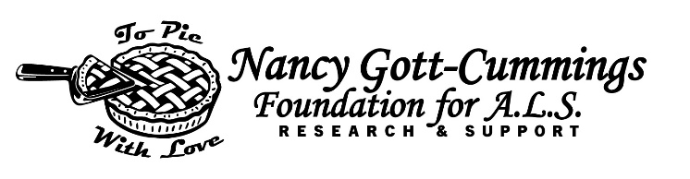
The Nancy Gott Cummings Foundation for ALS Research
C/O Allen Accounting Services · PO Box 1227 · Salmon, Idaho · 83467
info@NCGforALS.com · www.NCGforALS.com
VERIFICATION OF HEALTHCARE PROVIDER FORM
If this is your first time completing an application, you must submit a Verification of Healthcare Provider form
which must be completed by a licensed healthcare provider. Once this form is on file, you will not need to resubmit. If you are not sure we have a verification of diagnosis form on file, please send an email asking for verification to info@ngcforals.com.

To be completed by Patient or Caregiver
Patient Name: _____________________________________________________________________________
Address (P.O. Box will not be accepted) _________________________________________________________
City _____________________________________ State _________________ Zip ____________________
Home Phone ______________________________ Cell Phone ______________________________________
Date of Birth ______________________________ Email_____________________________________________
Licensed Healthcare Provider Name: __________________________________________Telephone: ________________
Address: __________________________________ ____City: ___________________State: ___________ Zip:_________
Hospital or Clinic: _________________________________________________________________________
Below information must be legible and filled out completely

______________________________________ (_____)___________________
Provider Name (Please Print) Phone

______________________________________ __________________________
Provider Signature Date

State Licensed In:_____________Specific Credentials:______________________

License #____________________________

Completed form may be scanned and emailed to info@ngcforals.com

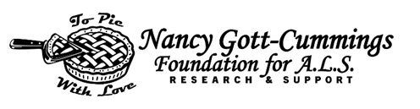
The Nancy Gott Cummings Foundation for ALS Research
C/O Allen Accounting Services · PO Box 1227 · Salmon, Idaho · 83467
info@NCGforALS.com · www.NCGforALS.com

Please read all conditions below and sign and date in the specified areas
The undersigned hereby agrees to the following grant conditions:

- To use the funds only for the designated purpose as described in the grant application and subsequent grant notification letter and not for any other purpose without the Foundation’s prior written approval..
- To provide records adequate to demonstrate that the grant funds were used for the purpose for which the grant is made, and to maintain records of expenditures adequate to identify the purposes for which, and manner in which, grant funds have been expended.
- To allow the Foundation to review and approve the content of any proposed publicity concerning this grant prior to its release and to recognize the Foundation in all publicity materials related to the funded project or program, as specified in the grant notification letter.
- To allow the Foundation to include information about this grant in the Foundation’s periodic public reports, newsletter, news releases, social media postings, and on the Foundation’s website. This includes the amount and purpose of the grant, any photographs you have provided, your logo or trademark, and other information and materials about your organization and its activities.
- Grant Recipient may announce and publicize the grant in recognition of Funder’s support. Grant Recipient and Funder may each disclose the other party’s name and the amount of the Grant, and use each other’s name or logo, in internal and external communications, including, without limitation, on it’s website and in it’s outreach materials, and as may otherwise be required by law. Neither Grant Recipient nor Funder will make any other public communications related to the Grant without the prior written consent of the other party. Grant Recipient and Funder will comply with any trademark guidelines that the other party may provide.

The Foundation reserves the right to discontinue, modify or withhold any payments under this grant award or to require a total or partial refund of any grant funds if, in the Foundation’s sole discretion, such action is necessary: (a) because you have not fully complied with the terms and conditions of this grant; (b) to protect the purpose and objectives of the grant or any other charitable activities of the Foundation; or (c) to comply with the requirements of any law or regulation applicable to you, the Foundation, or this grant.

Name of Patient:

Name of Caregiver (if applicable):

Grant Amount:

Patient or Caregiver Signature

Patient or Caregiver (Print) Date

